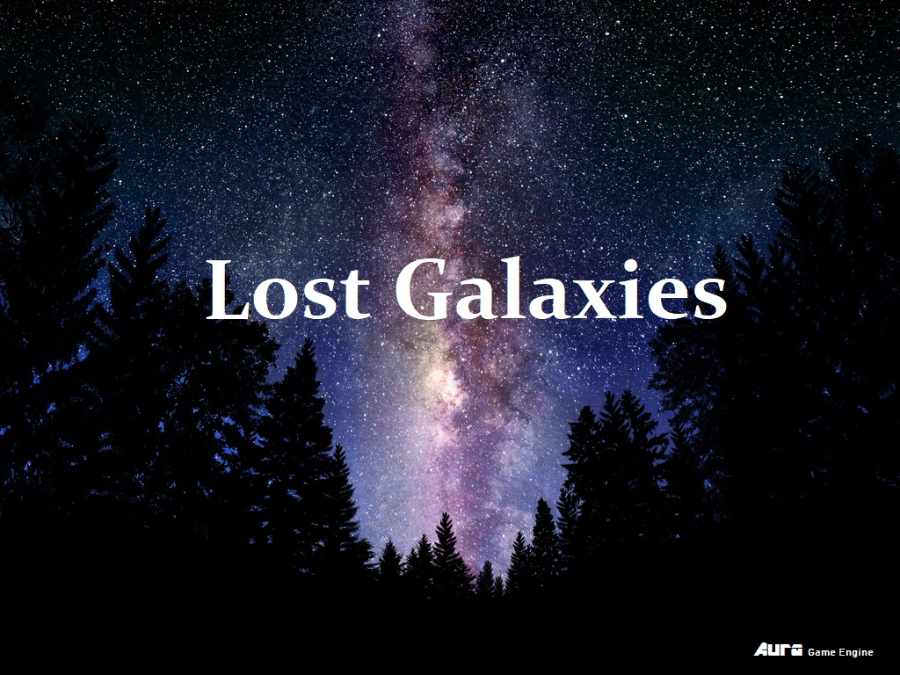

**By Anton Ziegler & Robert Esposito**

**GAME3015**

**Game Overview**

**Backstory:**

A massive war has erupted across the known universe. The aliens from Terra Venture have attacked Earth. You were in the middle of a hyper space jump when it happened, and now our solar system is just a bunch of demolished asteroids. As the last ranger in your squad, you must escape the asteroids floating around, before the Venturians come back for you.

**Gameplay:**

The game is a top down space shooter.

**Setting:**

The game is set in post-apocalyptic space, centered around where Earth should have been.

**Objective:**

The primary objective is to avoid or shoot the asteroids that appear on screen. The game is never ending, the objective is to simply survive for as long as possible.

**Key Features and Structure**

**Engine:**

The game will be created using an in-house engine, known as Aura Engine, in 2D.

**Input:**

The game will use a keyboard for input.

**Target Platform:**

The game will be created for windows PC.

**Architecture/Structure:**

Aura Engine starts in Main.cpp, it creates a splash screen, and then checks for game requirements. After the requirements are met, it starts the game, and creates a static GameObjManager called sceneGraph, it then proceeds into the game loop. The game loop continuously loops through the sceneGraph listOfObjs and updates them. In each gameObject that gets created, each one is given a Transform component that inherits from the c_BaseComponent class. The Transform component also has capabilities to translate, scale and rotate using the SFML library.

